Lab: Deploy PostgreSQL with Docker Volumes
Spin up a production-like PostgreSQL using Docker, attach persistent storage with volumes, verify data survives container replacement, and practice quick backup/restore.

Learning objectives
- Understand named volumes vs bind mounts and when to use each
- Run PostgreSQL with a named volume for persistent data
- Seed and query data using psql
- Prove persistence by recreating the container
- Take a logical backup and restore it

Prerequisites
- Docker installed and running (Linux, macOS, or Windows)
- Terminal/PowerShell
- Port 5432 free on your host

Step-by-step

1) Pull the image (pin a version)
docker pull postgres:16

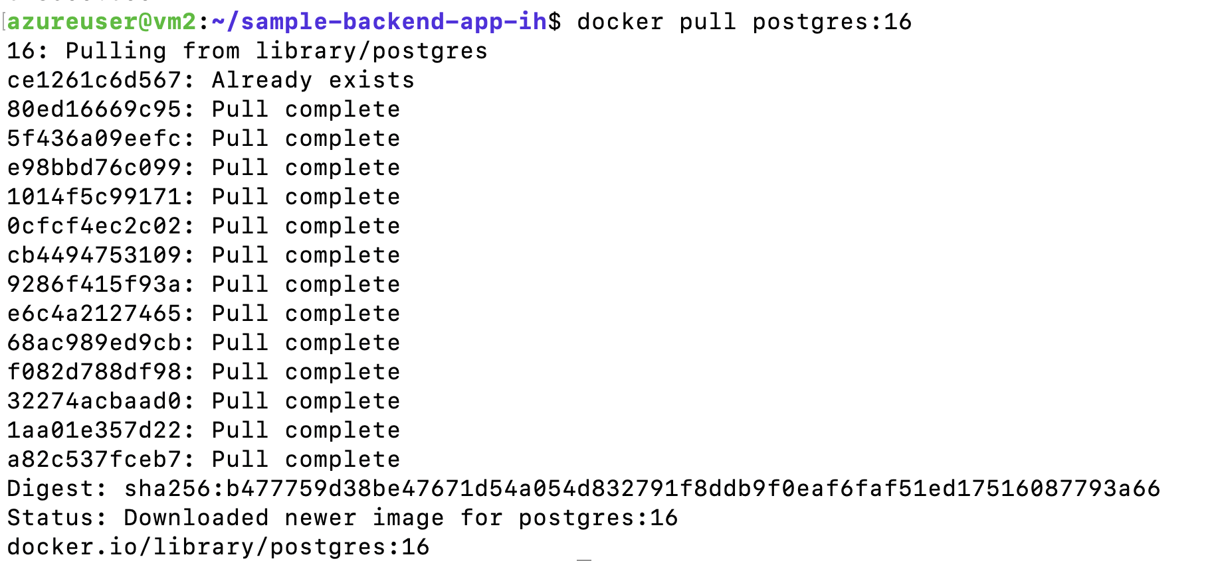

2) Create a named volume for data
docker volume create pgdata
docker volume ls

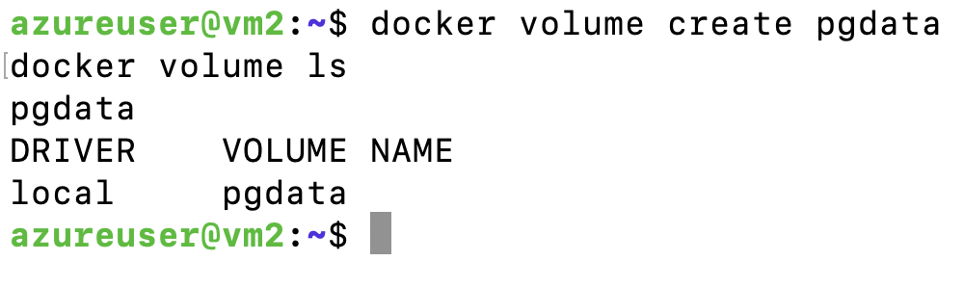

3) Start PostgreSQL with the volume attached
docker run -d --name pg-db \
-e POSTGRES_USER=appuser \
-e POSTGRES_PASSWORD=StrongP@ssw0rd \
-e POSTGRES_DB=appdb \
-v pgdata:/var/lib/postgresql/data \
-p 5432:5432 \
--health-cmd="pg_isready -U appuser -d appdb" \
--health-interval=10s --health-timeout=5s --health-retries=5 \
postgres:16

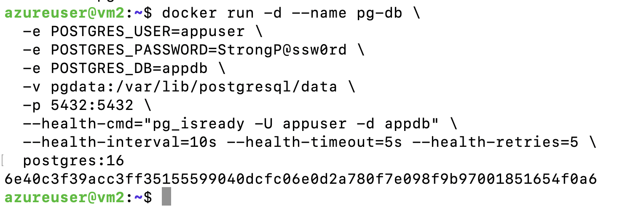
Check health:
docker ps --format "table {{.Names}}\t{{.Status}}\t{{.Ports}}"
docker inspect --format='{{json .State.Health.Status}}' pg-db
Wait until health is "healthy".
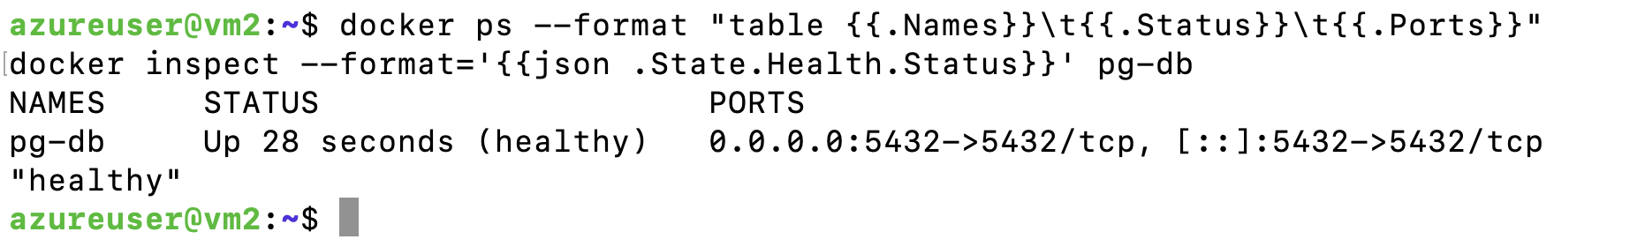

4) Connect with psql (from inside the container)
docker exec -it pg-db psql -U appuser -d appdb
At the appdb=# prompt, run:
CREATE TABLE notes(id serial PRIMARY KEY, msg text not null);
INSERT INTO notes(msg) VALUES ('hello, docker volumes'), ('persists across restarts');
SELECT * FROM notes;
\q

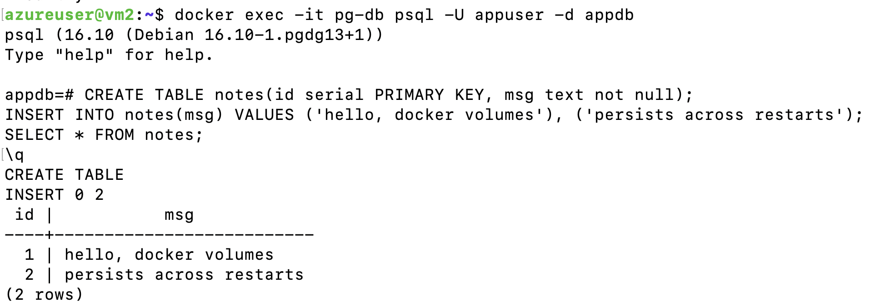

5) Prove persistence (remove & recreate the container)
Stop + remove container only (keep the volume):
docker rm -f pg-db

Start a new container pointing at the same volume:
docker run -d --name pg-db \
-e POSTGRES_USER=appuser \
-e POSTGRES_PASSWORD=StrongP@ssw0rd \
-e POSTGRES_DB=appdb \
-v pgdata:/var/lib/postgresql/data \
-p 5432:5432 \
postgres:16

Reconnect and confirm the rows still exist:
docker exec -it pg-db psql -U appuser -d appdb -c "SELECT * FROM notes;"

You should see the same data.
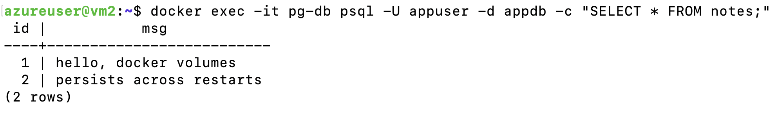

6) Inspect where Docker stores the volume (read-only curiosity)
docker volume inspect pgdata
# Look at "Mountpoint" (Docker manages this path for you)

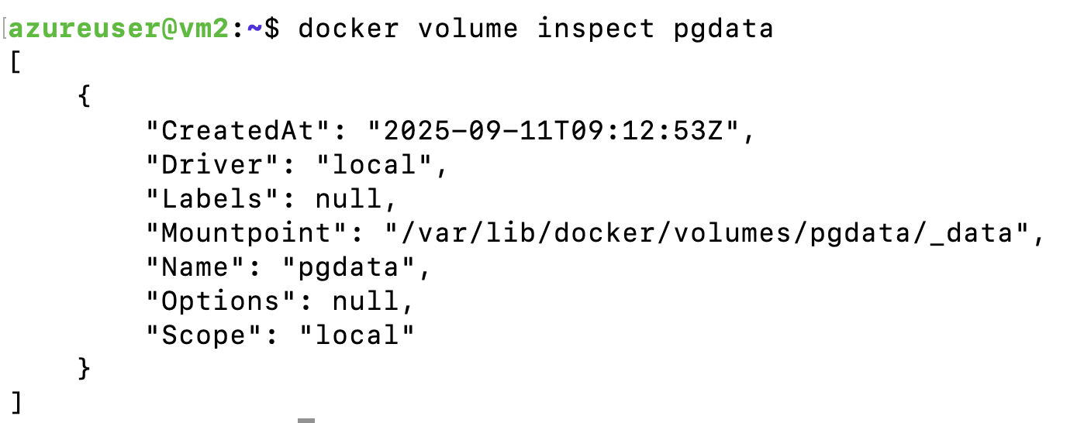

Use a bind mount instead of a named volume
Good for easy host-side browsing of files.
mkdir -p ./pgdata
# On Linux, if you hit permissions issues:
# sudo chown -R 999:999 ./pgdata (postgres user inside container is UID 999)

docker rm -f pg-db
docker run -d --name pg-db \
-e POSTGRES_USER=appuser \
-e POSTGRES_PASSWORD=StrongP@ssw0rd \
-e POSTGRES_DB=appdb \
-v "$(pwd)/pgdata:/var/lib/postgresql/data" \
-p 5432:5432 \
postgres:16

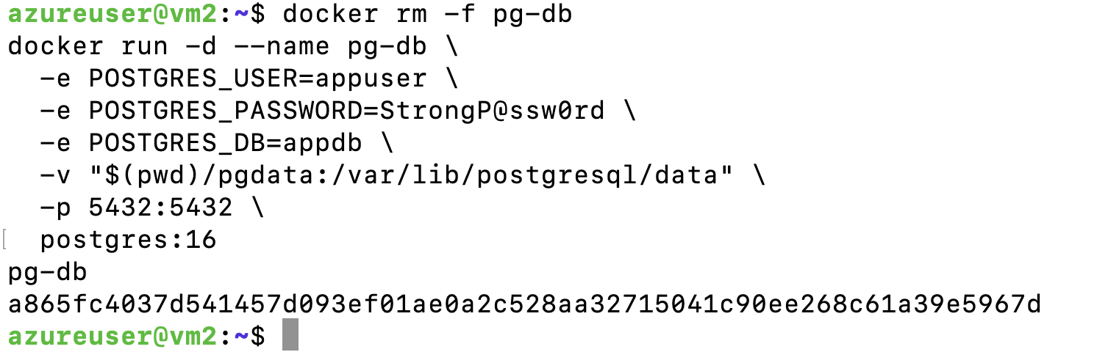

B) Seed DB on first run with init scripts
Anything in /docker-entrypoint-initdb.d runs only on the first init of an empty data directory.
mkdir -p initdb
cat > initdb/001_init.sql <<'SQL'
CREATE TABLE todos(id serial PRIMARY KEY, task text NOT NULL);
INSERT INTO todos(task) VALUES ('learn docker volumes'), ('write a great lab');
SQL

docker rm -f pg-db
docker volume rm pgdata
docker volume create pgdata

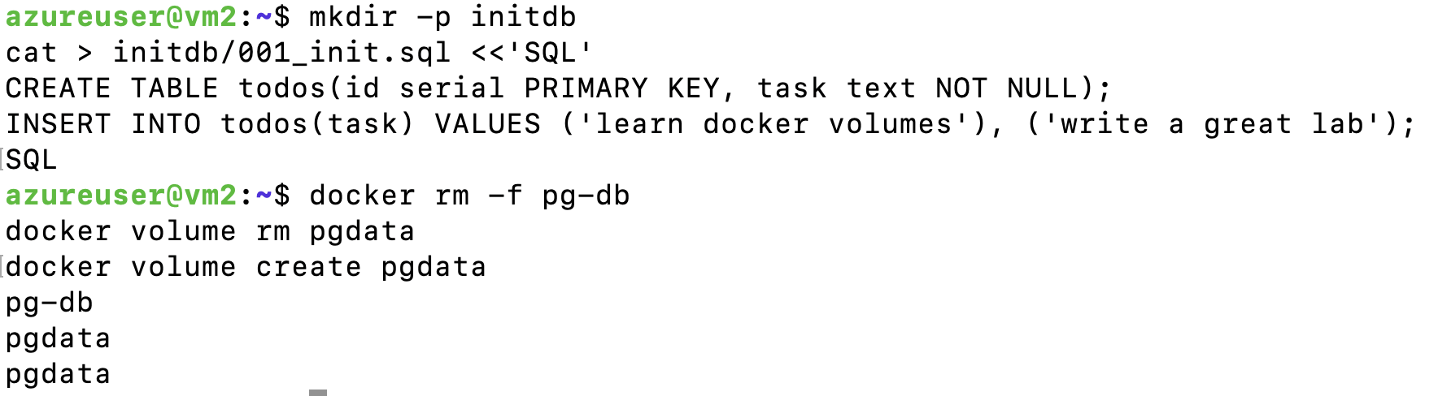

docker run -d --name pg-db \
-e POSTGRES_USER=appuser \
-e POSTGRES_PASSWORD=StrongP@ssw0rd \
-e POSTGRES_DB=appdb \
-v pgdata:/var/lib/postgresql/data \
-v "$(pwd)/initdb:/docker-entrypoint-initdb.d:ro" \
-p 5432:5432 \
postgres:16

# Verify:
docker exec -it pg-db psql -U appuser -d appdb -c "SELECT * FROM todos;"

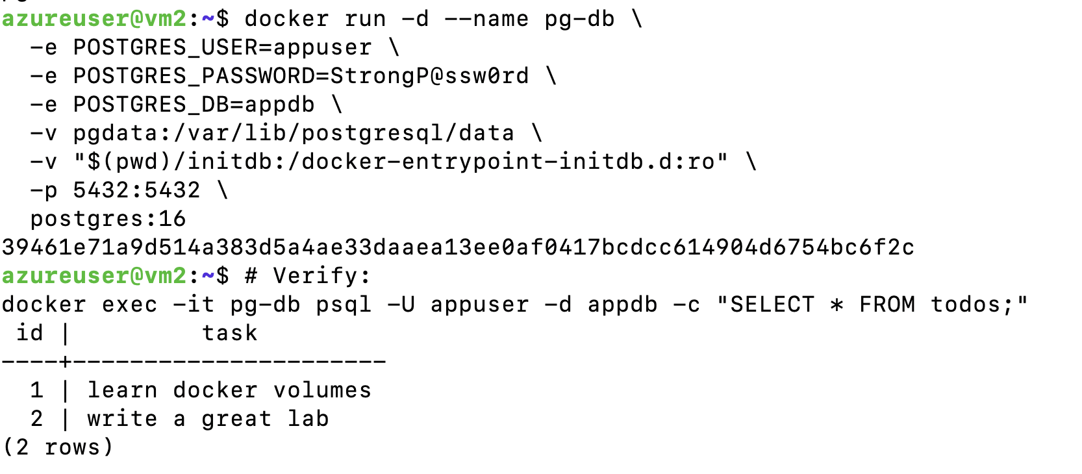

C) Quick backup and restore
Backup (logical dump to a host folder):
mkdir -p backups
docker exec pg-db pg_dump -U appuser appdb > backups/appdb_$(date +%F).sql

Restore into a fresh DB (example: new container/db name):
docker run -d --name pg-restore \
-e POSTGRES_USER=appuser -e POSTGRES_PASSWORD=StrongP@ssw0rd -e POSTGRES_DB=restored \
-v pgdata_restore:/var/lib/postgresql/data -p 5433:5432 postgres:16

# Load the dump
cat backups/appdb_*.sql | docker exec -i pg-restore psql -U appuser -d restored

# Verify
docker exec -it pg-restore psql -U appuser -d restored -c "\dt"

D) Store credentials in an env file (cleaner than inline)
Create .env:
POSTGRES_USER=appuser
POSTGRES_PASSWORD=StrongP@ssw0rd
POSTGRES_DB=appdb

Run:
docker rm -f pg-db

docker run -d --name pg-db --env-file ./.env \
-v pgdata:/var/lib/postgresql/data -p 5432:5432 postgres:16

Note: In real production, use a secrets manager (and TLS).

Troubleshooting
- Port 5432 already in use: Stop the other service or change mapping to -p 5433:5432.
- Permission denied on bind mount (Linux): sudo chown -R 999:999 ./pgdata.
- Env mistakes on first run: If you change POSTGRES_* after data dir is initialized, it won’t re-init. Remove/recreate the volume to re-init.
- Healthcheck stays starting: Check logs: docker logs pg-db. Often a bad password or a busy port.

Cleanup
docker rm -f pg-db pg-restore 2>/dev/null || true
docker volume rm pgdata pgdata_restore 2>/dev/null || true
rm -rf ./pgdata ./initdb ./backups 2>/dev/null || true

